# Overview:

This document describes the special power that the player acquires upon taking photos of specific objects. Player would use left click to cast these spells.

### Billboard:

Players release a splash of electrics around him and deals (X) damage to enemies around them. Disable their movements for 1 second.

Number of uses: 3.

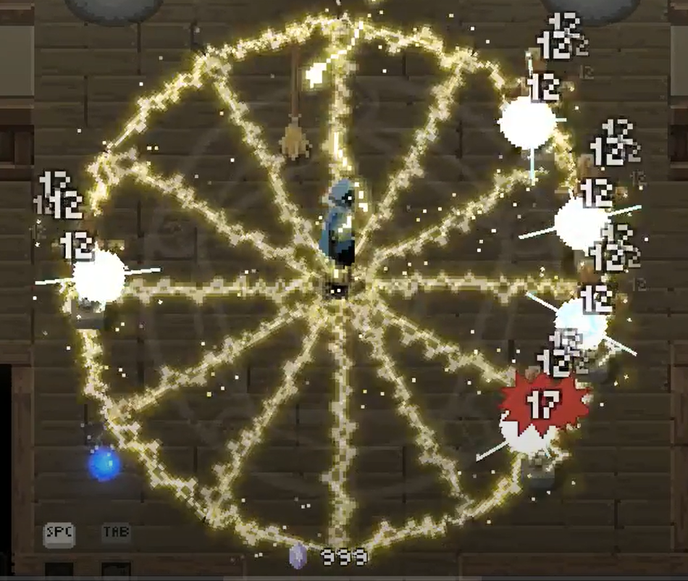

### Spring:

Player dashes in the direction they are facing.

Number of uses: 5.